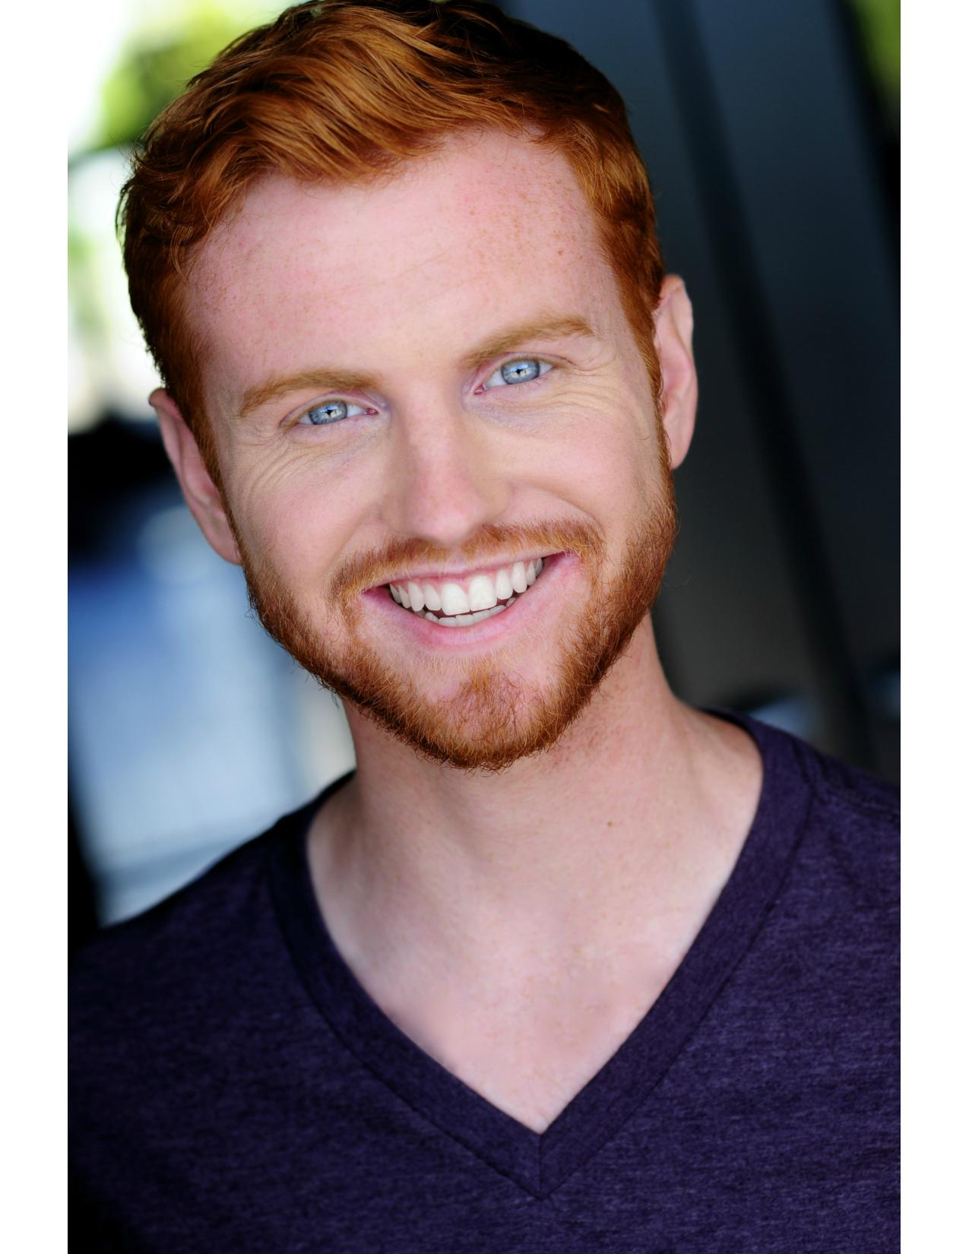
Jordan Woods
EMC
Email: Jt.woods@yahoo.com Phone: 1(314)680-6533
Website: JordanThomasWoods.com He/Him
Voice Type: Baritone Hair: Red
Eyes: Blue Height: 5’10”

Regional Theatre

Macbeth: Come Like Shadows* Head of Security/Asst. Dir. Rebel and Misfits Productions
Aurum 2.0* Ensemble ACE Dance Concept (Paris, France)
Love at First Fright* Frankie Six Flags St. Louis
Miss Kitty’s Saloon* Swing in Performance Six Flags St. Louis
Pipeline Gala Dancer/Announcer The Midland Theatre
The Scenic Route Dancer /Swing Consuming Kinetics Dance Co.
Fiddler on the Roof Avram Tent Theatre
Club Eternity* Cato RWS Entertainment Group
Bloom Dancer Consuming Kinetics Dance Co.
Yule Ball* Charlie Weasley Jr. The Foundry
Chicago (w/ Patti Murin) Teen Ensemble The Muny
Shrek the Musical (w/Rob McClure) Dragon Puppeteer/Teen Ensb. The Muny
One Man, Two Guvnors Alfie Pioneer Playhouse
Urinetown Hot Blades Harry Next Generation Theatre
Polar Express Train Ride* Chef/Hobo Union Station St. Louis
Shatterer of Worlds* Puppeteer Bread and Puppet Theatre Co.
*Immersive/Interactive
University Theatre

Hair Berger Missouri State University
Dogfight Bernstein Missouri State University
Tartuffe Damis Missouri State University
Angels in America Martin Heller Missouri State University
Razia’s Shadow: The Musical Ahrima/Adakias Tabula Rasa
Movement in Flux Dancer/Singer/Tapper Spring Dance Concert

Training

Missouri State University – B.F.A. Musical Theatre
Dance: Consuming Kinetics Dance Company Artist (St. Louis, Mo. 2018-19)
Contemporary, Hip Hop, Contact Improv, Ballet, Afro-Jazz – Advanced Tapper
Viewpoints: Lucy Cashion, Maggie Marlin-Hess, and Ruth Barnes
Movement: Red Nose Clown and Neutral Mask - Jef Awada, Butoh - Jane Tellini
Immersive Technique - Kelly Hummert, Bouffon - Audrey Crabtree, Suzuki Method - Chuck Harper
Puppetry Workshops: Bread and Puppet Theatre Company Intensive and Jenny Lale Winter Intensive
Stage Combat: Unarmed and Rapier with Kurt Heinlein
Improv Workshops: CORE Improv Technique

Special Skills
Spinning Fire/LED Poi, Intermediate Tenor Saxophone, Basic Bass Guitar, Basic Ukulele, Tarot Card Reader
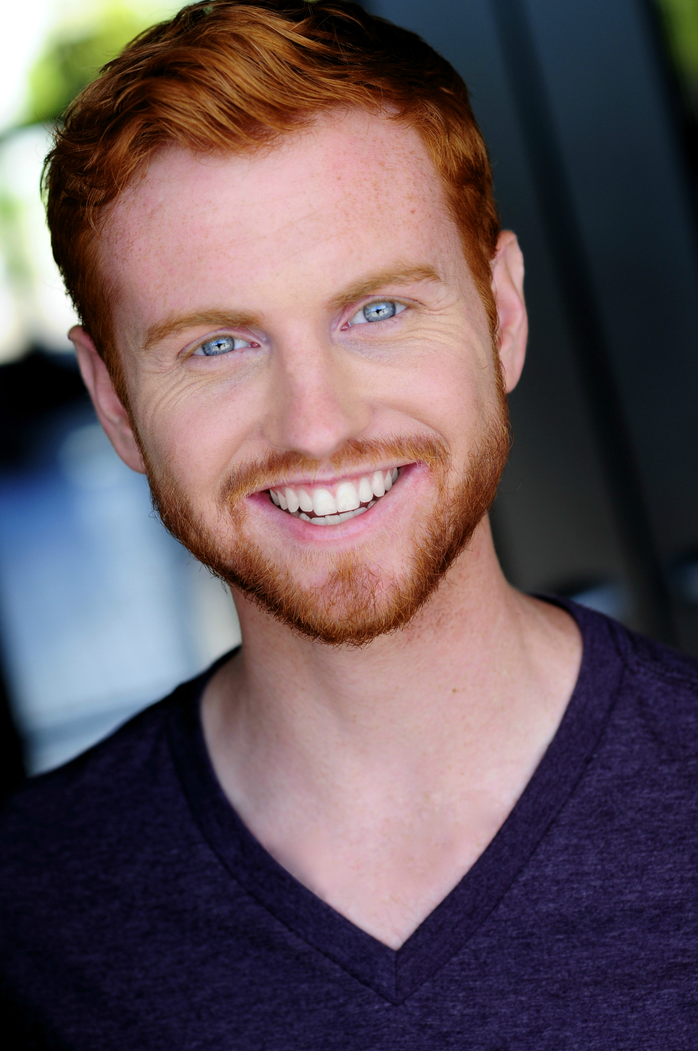
Jordan Woods

